spectrum of services

LEADING PROVIDER OF DATA ANALYTICS SOLUTIONS
Digital Nest Solutions is a leading provider of data quality services like MRO Data Cleansing Services, Material Master Data Management Solutions and services like Product Data Solutions, Product Information Management, Product Data Development services, Regulatory Compliance, Supplier Data Management Services, Onsite Data Sourcing Service, and Data Classification Services, for global customers. We work with EAM/MDM implementers, suppliers, manufacturers, eCommerce, and supply chain integrators. Our unique scalable process is designed to leverage the right mix of content knowledge and domain expertise in order to deliver low cost, high quality content. For over 10 years, we have been successfully helping many customers in MRO, Ecommerce, Manufacturers and Vendors, Electronics and Electrical, Energy, Oil and Gas, Chemicals, Constructions, Automotives, Power & Utilities and other Engineering Domains.
We deliver high-performance services to help your business embrace innovation and tackle the ever-changing challenges of today’s digital world. Designed to meet your specific needs, our services capture and deliver business value in a cost-effective way. Based on your strategic objectives, we focus on business outcomes in software engineering, development teams, digital consulting, and solution operations.
Digital Nest Solutions has evolved over the years as one of the best IT-enables outsource data services company in India today. We provide the latest and most competitively priced IT services to help our clients expand their business. With our expertise, we provide you with strategies to help you improve the quality of servicing, increase productivity, improve operations and better your business quality. With our experts you will get the advantage of experience and great multi tasking abilities. Our team has years of experience in the fields of Data processing, Knowledge process outsourcing, KPO services, E-commerce and catalogue processing services. At ……… we combine our clients’ needs with cutting edge IT services to provide the best results.

A data scientist is someone who can obtain, scrub, explore, model, and interpret data, blending hacking, statistics, and machine learning. Data scientists not only are adept at working with data, but appreciate data itself as a first-class product.
The goal is to turn data into information and information into insight.

Data-Engineering
Our Data Engineering processes help you to develop robust capabilities to deal with all sorts of data tasks like volume, velocity, veracity and the prowess to handle the various data types. This is incepted by implementing Data Lakes that act as the foundation of data to develop a range of analytical solutions.
Eventually, Data Pipelines are developed that take the data out of the sandbox environments and onto the hands of the end-users. Finally, value is realized since the operational costs of Data Science solutions are reduced and new revenue sources can be discovered.

Data Services, we have a stellar track record of providing eCommerce product data management services to our customers in an inclusive variety of business verticals. Some of the key services provided by our eCommerce Product Data Management team include:
- Data Cleansing
Data cleaning is the process of preparing data for analysis by removing or modifying data that is incorrect, incomplete, irrelevant, duplicated, or improperly formatted. This data is usually not necessary or helpful when it comes to analyzing data because it may hinder the process or provide inaccurate results. There are several methods for cleaning data depending on how it is stored along with the answers being sought. Data cleaning is not simply about erasing information to make space for new data, but rather finding a way to maximize a data set’s accuracy without necessarily deleting information. For one, data cleaning includes more actions than removing data, such as fixing spelling and syntax errors, standardizing data sets, and correcting mistakes such as empty fields, missing codes, and identifying duplicate data points. Data cleaning is considered a foundational element of the data science basics, as it plays an important role in the analytical process and uncovering reliable answers. Most importantly, the goal of data cleaning is to create data sets that are standardized and uniform to allow business intelligence and data analytics tools to easily access and find the right data for each query.

- Data Enrichment
Data enrichment is refers to processes used to enhance, refine or otherwise improve raw data. This idea and other similar concepts contribute to making data a valuable asset for almost any modern business or enterprise. It also shows the common imperative of proactively using this data in various ways.
Includes enhancing the quality and richness of data, extracting and developing attributes, manually sourcing additional data and information from suppliers and manufacturer websites.
Another way that data enrichment can work is in extrapolating data. Through methodologies such as fuzzy logic, engineers can produce more from a given raw data set. This and other projects can be described as data enrichment activities.

- Data Model
Data modeling is to creating a data model for the data to be stored in a database. This data model is a conceptual representation of Data objects, the associations between different data objects, and the rules. Data modeling helps in the visual representation of data and enforces business rules, regulatory compliances, and government policies on the data. Data Models ensure consistency in naming conventions, default values, semantics, security while ensuring quality of the data.

- Data Classification
Product data classification is a vital portion of product data management. It is an elaborate and challenging task because of the heterogeneity of taxonomic codes and classification schemas used by vendors. They have a tendency to vary expressively from country to country and manufacturer to manufacturer. For example, an extensively used classification schema in the US is UNSPSC. Moreover, there is UPC, used in the US, UK, Australia and New Zealand and also eClass, used both in Germany and the US. Hence, after take out product data from rough sources, one might discover that it follows to a great variety of classification schemas.

- Schema Mapping
A high-level, declarative specification of the relationship between two database schemas, typically called the source schema and the target schema. Schema mappings form the backbone for specifying and carrying out data-interoperability tasks involving data across different sources.

- Data Codification (UNSPSC,ecl@ss, SIC,NAICS,Custom Taxonomy)
Data Codification it to transforming collected information or observations to a set of meaningful, cohesive categories By coding data, researchers classify and attach conceptual labels to empirical objects under study in order to organize and interpret them in the given research context.
Includes classification of products to UPC, UPN, UNSPSC, eClass, SMD, NAICS, SIC, EGII, JPPSG, MESC, NIGP, ECRI, NDA or any other taxonomies.

- Taxonomy Development
Better taxonomy leads to quicker shopping, offering your customers a comprehensive view and prompt navigation to the product information they want.

An authoritative, partial and distinct list of terms, names, labels, categories, etc. – 'taxonomy' narrates to the science of classification, where each term stands for a diverse unambiguous concept – well-organized in a classified structure or grouping.
The taxonomy professionals at Adept Data Services work thoroughly with your eCommerce product data management teams to exactly evaluate the behavior of your prospects and customers, who search for your products over the web.

- Data Mining
Data mining is a very popular topic nowadays. Unlike a few years ago, everything is bind with data now and we are capable of handling these kinds of large data well.
By collecting and inspecting these data, people were able to discover some patterns. Even the whole data set is a junk, there are some hidden patterns that can be extracted by combining multiple data sources to provide valuable insights.
Data mining is often combined with various sources of data including enterprise data that is secured by an organization and has privacy issues and sometimes multiple sources are integrated including third party data, customer demographics and financial data etc.

- Data Standardization
Standardized product data also conveys a considerable long-term advantage for online retailers, in the sense that it recovers their competence in building, importing, and managing the product data, ensuring a higher level of consistency and data quality. Though, most eCommerce stores distrust the data available in their systems as they face serious problems with the quality of product data.

.
- Data Normalization
Normalization is a process used to organize a database into tables and columns. The main idea with this is that a table should be about a specific topic and only supporting topics included. Take a spreadsheet containing the information as an example, where the data contains salespeople and customers serving several purposes:

- Identify salespeople in your organization
- List all customers your company calls upon to sell a product
- Identify which salespeople call on specific customers.
By limiting a table to one purpose you reduce the number of duplicate data contained within your database. This eliminates some issues stemming from database modifications.

- Duplication & De-Duplication
Data duplication is an important mechanism by which evolution occurs.
Data deduplication is a technique used to reduce the amount of storage space an organization needs to save its data. In most organizations, the storage systems contain duplicate copies of many pieces of data. For example, the same file may be saved in several different places by different users, or two or more files that aren't identical may still include much of the same data.

- Imaging Sourcing and Editing
Image editing is considered a creative, artistic act. Image editing is done for removing unwanted elements such as dust specks and scratches, adjusting the geometry of the image like rotating and cropping, correcting for lens aberrations, sharpening or softening the image, making color changes or adding special effects to the image. Often the tasks involved in image editing are repetitive and need intense processing. Manual image editing done on traditional analog photographs requires a high level of expertise and attention to detail. Image editing software applications are also available for editing images. Unlike other conventional methods, these tools provide advanced image editing operations like data compression, photo organization and selection of image properties.

- Digital Assets Extraction
As a discipline and a technology, DAM is all about the control, flexibility, portability, access, and reporting of digital assets between organizations, customers, partners, and suppliers. (Digital assets are files that have an intrinsic or acquired value over their lifetime.)
DAM is concerned with delivering the right content to the right people, on all devices, mostly in real time, with the ability to track and measure digital asset engagement across an enterprise and its potential global reach.

Technically speaking, a digital asset is more than just the media file. To realize the value of a file (or collection of files), you need to have additional information about that asset. In short, you need metadata.

- SEO Keywords
Keywords are ideas and topics that define what your content is about. In terms of SEO, they're the words and phrases that searchers enter into search engines, also called "search queries.

- RoHS
RoHS has its roots in the European Union back in 2003. The goal of RoHS (Reduction of Hazardous Substances) is to reduce the environmental effect and health impact of electronics. The legislation's primary purpose is to make electronics manufacturing safer at every stage of an electronic device's life cycle.

- REACH
REACH is a regulation of the European Union, adopted to improve the protection of human health and the environment from the risks that can be posed by chemicals, while enhancing the competitiveness of the EU chemicals industry. ... REACH stands for Registration, Evaluation, Authorisation and Restriction of chemicals.

- SDS/MSDS
SDS includes information such as the properties of each chemical; the physical, health, and environmental health hazards; protective measures; and safety precautions for handling, storing, and transporting the chemical. The information contained in the SDS must be in English (although it may be in other languages as well). In addition, OSHA requires that SDS preparers provide specific minimum information as detailed in Appendix D of 29 CFR 1910.1200. The SDS preparers may also include additional information in various section(s).
A safety data sheet (SDS), material safety data sheet (MSDS), or product safety data sheet (PSDS) are documents that list information relating to occupational safety and health for the use of various substances and products.

- Material Master Data Management
Material Master Data Management is a comprehensive strategy to determine and build a single, accurate and authoritative source of truth for a company's information assets and typically deliver this as a service on demand. How it brings data means together to create a single, accurate record of the truth across the enterprise. Once created, this master data serves as a trusted view of business-critical data that can be managed and shared across the business to promote accurate reporting, reduce data errors, remove redundancy, and help workers make better-informed business decisions.
Material Master Data Management including business intelligence that allows organizations to encapsulate data and convert it into knowledge and benefits, this revolutionary method not only enabled companies to organize, categorize, and localize their master data according to the business rules of the sales but also concentrate on the marketing and operational strategies for their specific needs.
  - Improved efficiency
  - Eliminate poor quality data
  - Improved decision-making
  - Superior regulatory compliance
  - Redundancy Elimination
  - Master Data Edits
  - Useful and Effective Data Analysis
  - Key Data Goes In
  - Authoritative Data
  - Data Consistency
  - Flexibility & Increased Usability and Business Efficiency

- Equipment Master Data Management
Equipment Master Data Management involves organizing, structuring, storing, and tracking the product information created by the product design team as they carry out engineering and development activities, controls all product-related data and associated workflow processes within an enterprise.
Product Data and process-related information in a single, central system. This information includes effective data, models, parts information, manufacturing instructions, requirements, notes and documents. The ideal PDM system is accessible by multiple applications and multiple teams across an organization, and supports business-specific needs.
- Time-to-Market
- Improved Productivity
- Improved Control
- Find the correct data quickly
- Improve productivity and reduce cycle times
- Reduce development errors and costs
- Improve value chain orchestration
- Meet business and regulatory requirements
- Optimize operational resources
- Facilitate collaboration between global teams
- Provide visibility for better business decision-making

- Enterprise Asset Management

Enterprise asset management (EAM) combines software, systems and services to help maintain, control and optimize the quality of operational assets throughout their lifecycles. The aim is to optimize the quality and utilization of assets throughout their lifecycle, increase productive uptime and reduce operational costs.
companies can centralize all their asset information in one place, making it easier to monitor and optimize the assets and proactively inspect and maintain them. Planning and scheduling of tasks and workers is streamlined and automated, leading to increased productivity, while also safeguarding both workers and the environment. Key benefits include
- Integrated data stores
- Real-time decision-making
- End-to-end lifecycle management
- Improved environmental, health, and safety measures

Vertical Served for Energy and utilities, Chemicals, petroleum and mining, Manufacturing, Transportation, Transportation, Transportation and Nuclear power plant.

EAM offers a centralized repository for equipment tracking and performance analysis. To increases their potential, save time and money to know optimizes business risks and reduce.
Maximized ROI.
- Enhanced Decision Making.
- Productive utilization of assets.
- Better Efficiency.
- Improved Customer Experience.

- Material Information and Development Services
Product Information management systems replace paper-based processes and information storage with a single, centralized data repository. That enables authorized users throughout a company to access and update current product information while ensuring they follow specific procedures.
Our experts will enrich your product data so customers move from search to buying. Catalogs make it easier to deliver rich product content including product specifications, accessories, digital assets, and more in any language and on any device to customers, channel partners, and sales teams.
Product Data Development is one of the most valuable assets within an organisation. It needs to be accurate, complete and available at all times. Our services facilitate a deeper understanding of the structure and relationship of your data for better business decisions. We can deliver all or parts of our Data Enhancement modules to meet your needs.
Data Development is not just improvising on the existing data but it involves reducing bad data or rather unwanted to Clean, accurate and comprehensive customer and prospect data is the prerequisite to any sales, marketing and customer management strategy and can deliver a range of benefits for businesses but most importantly it can help boost your sales and increase the lifetime value of your customers. Enhancing or cleaning data also reduces customer defection which is simply the disinterested customers who can by no chance be interested in the product or brand again, despite several marketing techniques by the organization.
Product Data Enrichment is all about providing completeness of data and up to date information on the products. Nowadays customers visit your online store, but leave it in no time if they could not find the relevant information they needed. Enriched product data helps your customer is not to speculating about the particulars of your product, and thereby consequently reduces the rate of customer drop outs.
- Manufacturer-approved product content
- Easy to integrate
- International Standard
- Ensures that the product is completely understood with all the attributes
- Product Data Enrichment will Increase the engagement and revenue for the retailer
- Improve sales through a clean and attributed data capture
- Buyer will be able to make the proper selections based on the information that's correct
- Customers come to know more about the richness of product data and influences buying it
- Completeness of the information brings the reliability to the view
- Enhances Product Capabilities
- Data Security and improves productivity
- Reduce overhead costs associated with in-house management of product data
- Get search-optimized data taxonomies, product titles, and images
- Removing bad contacts which makes your database efficient
- Standardized and search-optimized, product content
- Ensure content accuracy and consistency across channel partners
- Reduce your product’s time-to-market

Digital Nest Solutions is one of the leading providers of data Solutions for e-Commerce, e-Procurement, Inventory Optimization, Spend Analysis for Global customers. We transform paper or electronic catalogs into rich, classified and transactable electronic content and deliver cost effective solutions through a combination of advanced technologies, proven processes and outstanding personnel. We are B2B and B2C company purely providing product information to the industries like retailers, wholesalers, distributors, suppliers, manufacturers and B2B e-Commerce. we also specialize in “SELL” and “BUY” side data.

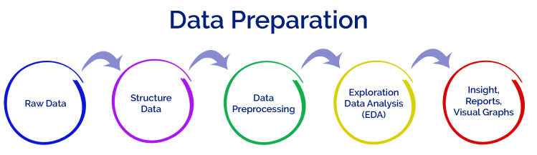
Our business is ideally made for e-Commerce / Web store / e-Catalog industries, We are a company with significant subject matter expertise. Over 90% of our work force are professional product analysts and almost all of them have relevant industry experience. our expertise range from Healthcare, Life Sciences, Mechanical, Electronic, Electrical, Safety, Furniture’s, Office Supplies, Building Supplies, Consumables etc. and all other MRO verticals. We have been a long term partner within this channel for several PIM/MDM companies as well as are the first choice for product data management within retail.

Facilities: Digital Nest Solutions operates basically from Mysore in India. Digital Nest Solutions employs over 50 to 100 highly experienced professionals and domain experts in its content division.
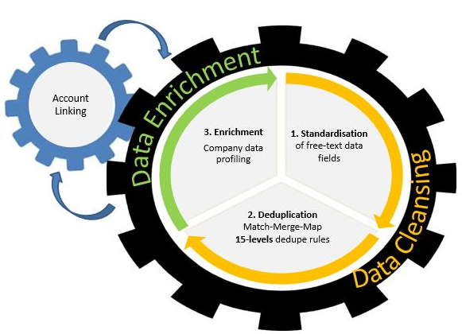
Quality: Quality is an Integral part of our “Core Business Model”. Our quality statement is also considerate of cost effectiveness, customer demands and satisfaction and on-time deliveries. We strive to continuously improve and meet global quality standards. We comply with all international standards and regulatory requirements
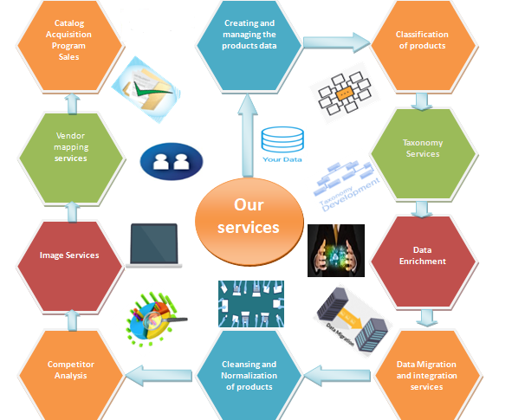

Digital Nest Solutions provide end-to-end big data solutions at enterprise scale because we bring world-class innovation and assets, advanced analytics skills, client experience and solutions for specific industries as well as across functional areas. We build a technology ecosytem to drive business results from data by harnessing emerging technologies.
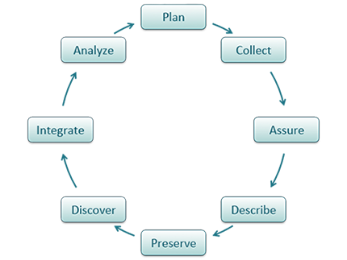
Data Management Benefits
• Increased Revenue
• Improved Customer Service
• Enhanced Marketing
• Increased Efficiency
• Cost Savings
• Enabling New Applications
• Improved Accuracy for Analytics
• Competitive Advantage

Data Management Best Practices
• Create a written strategy and policies for data lifecycle management
• Identify and protect sensitive data
• Deploy strong identity and access management controls that include an audit trail
• Invest in training for employees
• Enable data sharing across your organization
• Consider appointing a chief data officer

